**Air Pollution in India’s Four Cities Pre and Post COVID-19**

Brandon Mohammed, Sanjaye Thomas, Emma Lipari, Shivani Thakkar, Anjelica Ramsey

**Project Description/Outline**

Air pollution refers to the release of pollutants into the air that are detrimental to human health and the planet as a whole. Most of these air pollutants come from burning fossil fuels that release gases and chemicals into the air [(*The Natural Resources Defense Council*)](https://www.nrdc.org/stories/air-pollution-everything-you-need-know). With the current lockdowns of COVID-19, [India’s consumption](https://www.marketwatch.com/story/covid-19-lockdown-brings-fresher-air-cleaner-rivers-in-india-2020-04-22) of these fossil fuels have drastically decreased. In this project, we will analyze and create visualizations that compare the air pollution in India’s four major cities pre and post COVID-19 times.

**mhj**

**Research Questions to Answer**

How has COVID-19 affected air pollution in four major cities in different regions of India?

**Rough Breakdown of Tasks**

API: [OpenAQ](https://openaq.org/#/?_k=taler8)**,** [Archived CSV files](https://openaq-data.s3.amazonaws.com/index.html)

Analysis Study Structure: [Longitudinal and Cross Sectional Studies](https://www.iwh.on.ca/what-researchers-mean-by/cross-sectional-vs-longitudinal-studies)

Data Timeline Available:

|  |  |  |
| --- | --- | --- |
| Available Data  6/29/2015 - 4/6/2018 | No Data  90 days ago to 4/6/2018 | Available Data  90 days ago to present |

*Visualizations*

1. Summary Table - Mumbai(West)/Delhi(Northcentral)/Chennai(South)/Patna
   1. Mean, Median, Range, Stvd, SEM, IQR 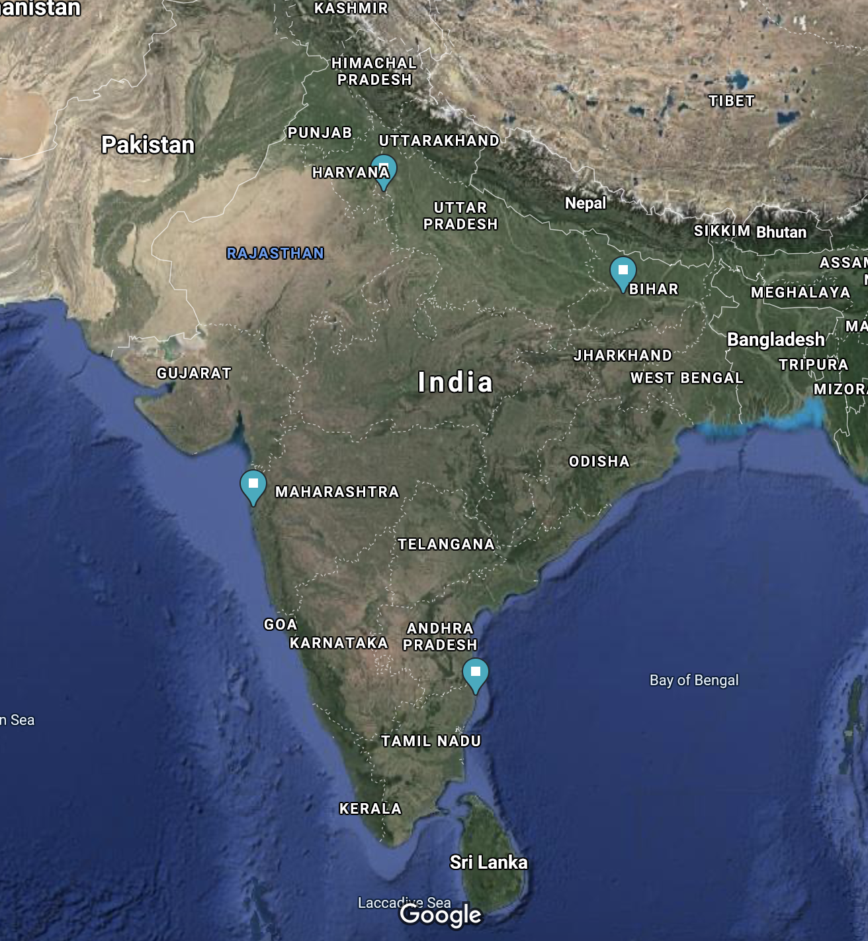
      1. PreCOVID 2017 - *EX: 5/1/2017*
      2. COVID Present - *EX: 5/1/2020*
2. Box Plot of CO2 in each city
   1. 2 visualizations that capture outliers
      1. PreCOVID 2017
      2. COVID Present
3. Pie Chart of pollutants each city
   1. Timeframe: Present, within 90 days
4. Types of Pollutants (NO2, PM25, CO, O3, SO2)
5. Pandas/Plyplot if more visualizations needed
6. Scatter Plot [one city] CO2 levels throughout day
   1. PreCOVID 2017 vs COVID present
   2. Determine the time range (cut off) for morning, afternoon, evening
   3. X-value: time; y-value: Mean CO2 within time of day

Brainstorming: Pinpoint location of each city in relation to factories, population to determine if there is a correlation?